Examination of opportunities on participating in sequential energy markets and identification of possible systematic price differences

In the following, the intended business goal of examining sequential markets is briefly explained in its essential core points:
An energy trading company represents the client in the case of this investigation. This stakeholder wants a study of price fluctuations and deviations in sequential markets in order to exploit arbitrage opportunities. In this way, the profit from energy sales for the company can be optimized or even maximized. Therefore, the client could benefit significantly from the analysis and prediction of price differences, fluctuations and volatilities.
A permanent implementation of the data analysis required to fulfill the pursued business goal would allow the company to split its available energy in the different markets more effectively. The planned undertaking could also have the side effect that mostly incalculable energy yields, such as the yields through different renewable energies sources, could experience a better integration into the system of the existing energy market. More specifically, these incalculable energy quantities could benefit from strengthening the short-term electricity markets due to a more strategic placement of energy across different markets.
The business goal is related to the problem of the insufficient orientation of energy prices to the respectively current demand. As well it addresses the challenges created by parallel participation in several markets, which has become essential mostly due to renewable energies.
Identifying a systematic in the price differences of sequential markets and through this deriving a recommendation for pricing auction offers would be considered a success. From that would increase the effectiveness of dealing with the energy market’s price volatility and this would ensue a decrease of current opportunity costs.

3. Analytics/Data Mining Goal:
(a) A description of the analytics objective.
Identify parameters responsible for the price difference between the day-ahead and intra-day auctions. Develop a regression model based on these parameters
(b) Is this a supervised or unsupervised task?
Supervised (price data is available)
Is it predictive or descriptive?
First part is descriptive, second part is predictive
Is it retrospective or forward-looking?
Both parts are retrospective, however the regression model can be used for prospective predictions too (assuming the utilized paremeters’ data is available at the point of prediction)
(c) What is the main outcome variable(s) of interest?
One or several parameters which have a causal relationship with the prices at both auctions and the kind of their relationship
4. Data:
(a) Brief description of available data.
The volume (in MWh) and price (in €/MWh) of the energy sold at each auction sale. For the day-ahead auction the data is hourly, for the intraday auction the data is available in 15-minute increments
(b) Some guidance on the data subset that will be used and the re-processing or preparation that might be needed based on your past experience.
First of all the data needs to be scraped from the respective websites. Then the hourly data needs to be converted into 15-minute increments and merged with the intraday auction data into one DataFrame. Since there is no missing data, no respective preparations are required. A Pandas TimeStamp will be used as the primary key. An additional column will be created for the price premiums.
(c) Sample of ten rows (records) with ten columns (variables) that will be used.
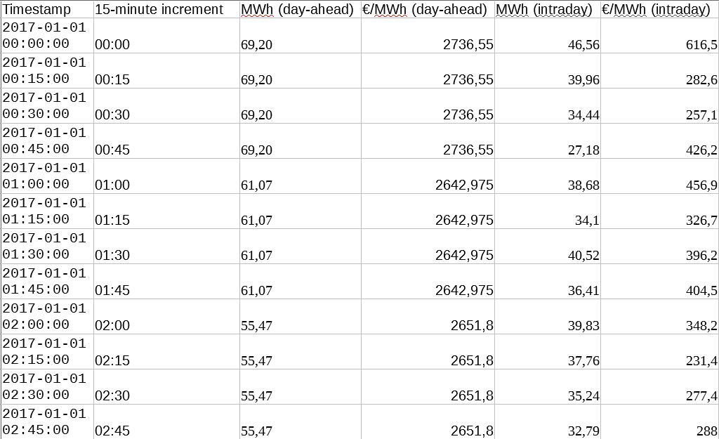
5. Methods:
(a) What are some data mining methods to consider?
-Supervised
-Batch learning
-Model based learning (statt instance based learning)
-(Teil 1) Deskriptiv, (Teil 2) Prediktiv
(b) Which performance measures are appropriate?
For the descriptive measuring goodness of fit is appropriate. For the predictive model the prediction accuracy on the holdout set compared to the training set.
How do they map to the business goal?
The goodness of fit shows if the derived parameters are responsible for the price difference between the auctions. The prediction accuracy shows how well the causal relationship between the parameters and the price has been estimated

6. Implementation/Production:
(a) Operational requirements or constraints (for example, will the solution be run in real-time? will it require collecting new data? will it be a one-time analysis or ongoing?)
The predictive model will not be continuously run in real-time, however it certainly can be used for that. This would however require automated data collection, automated data preparation, a thorough monitoring system, and a backup system in case the prediction performance deteriorates too much

